National Youth Ballet’s Performance Company auditions are now open!

OUR MISSION:
- We bring young people together | 
- We do creative, joyful and inclusive ballet | 
- We build confidence, skills and positive values | 
- Young people achieve | 
- Young people give ideas for the future of ballet | 

WHAT IS OUR PERFORMANCE COMPANY?

- The dates are: Sunday 10 August 2025 - Saturday 16 August 2025

- For young ballet dancers aged between 9 and 18 | 
- Location is Elmhurst Ballet School | 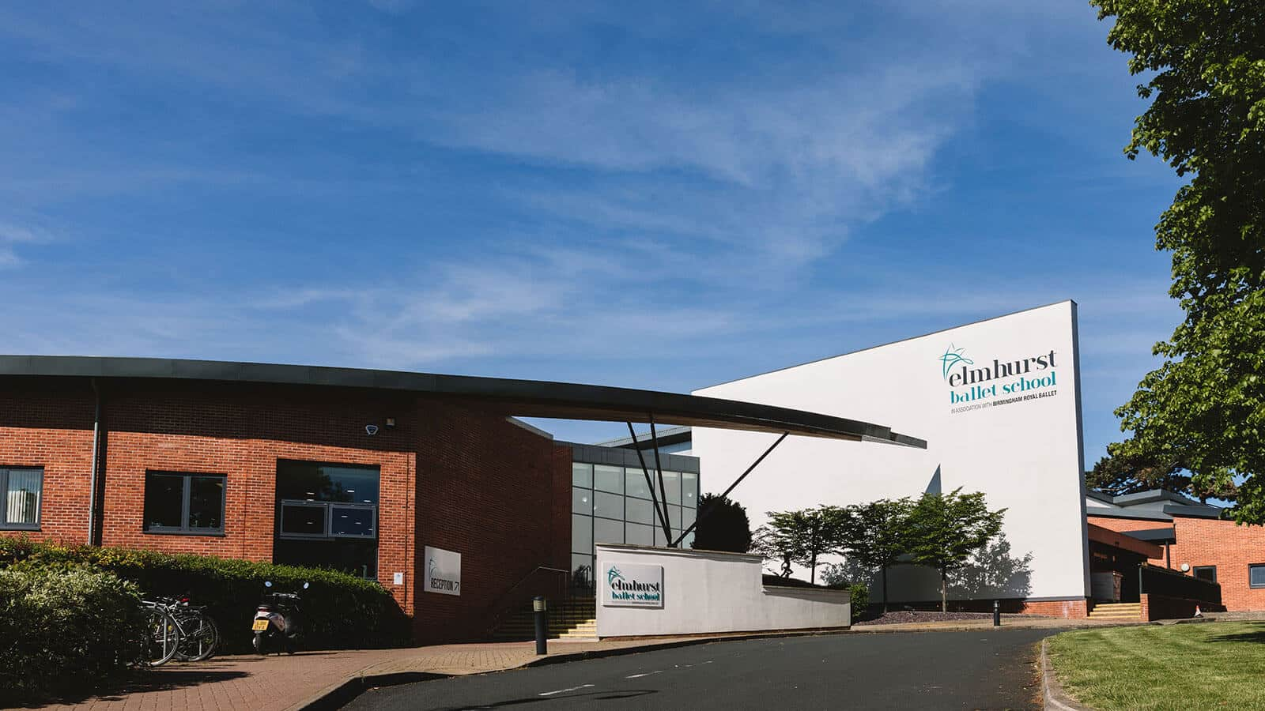
- Lasts for seven days | 
- You can sleep at Elmhurst Ballet School | 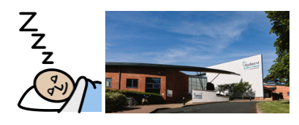
- You will work together as a group
- You will dance and learn new steps | 
- You will build confidence
- You will perform at the end | 

AUDITIONS

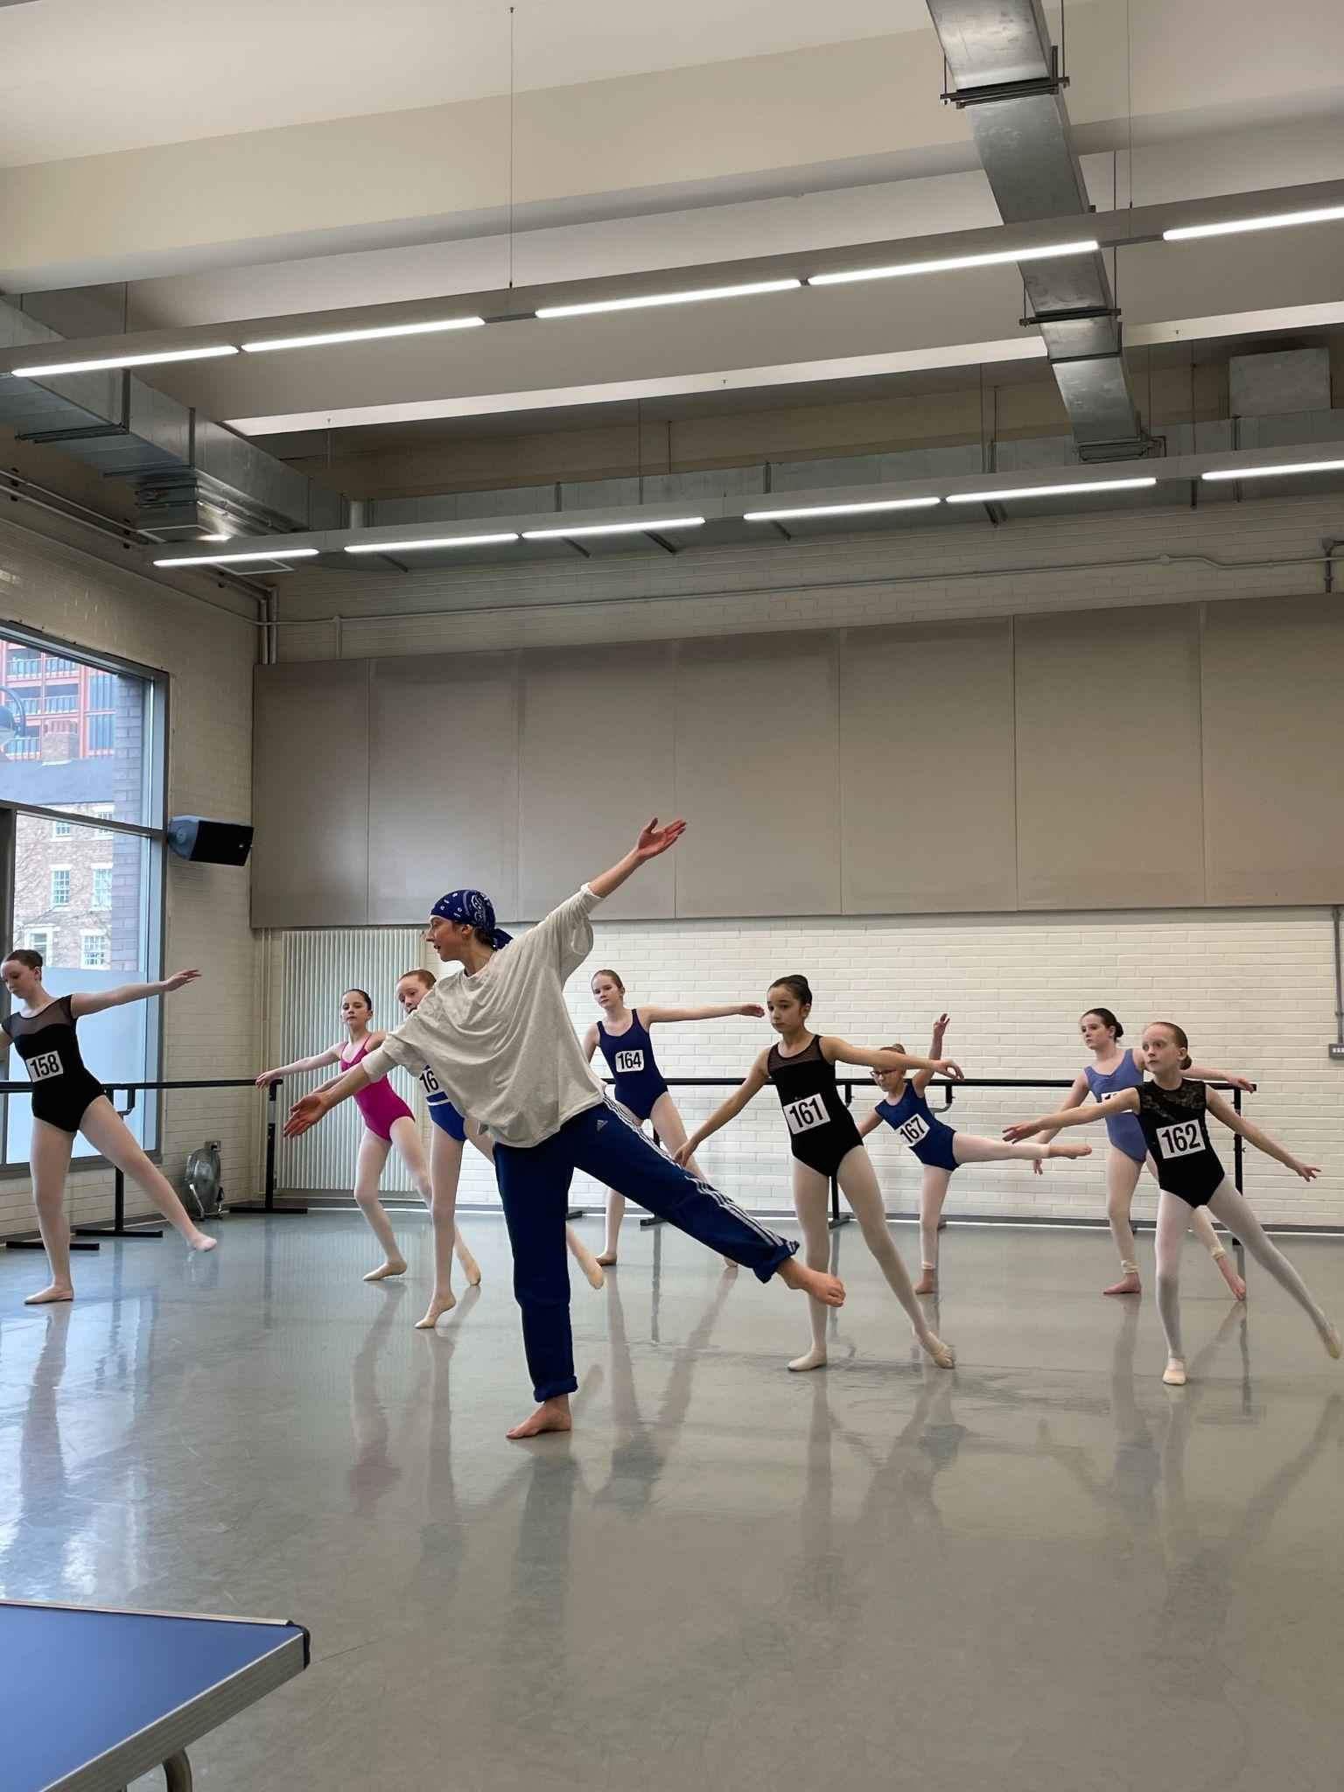
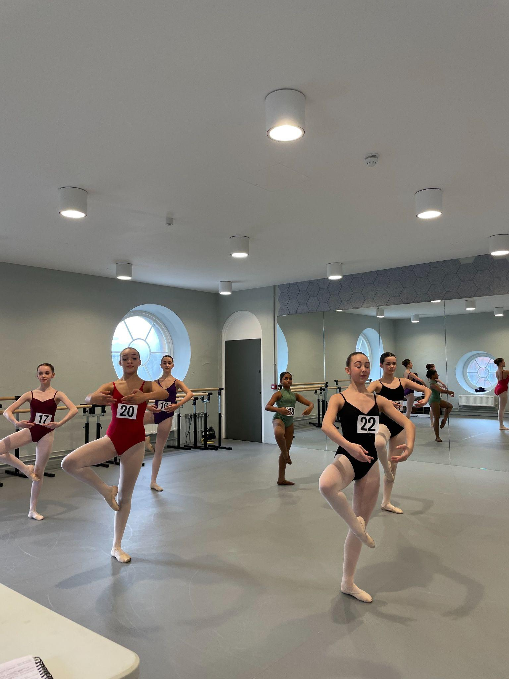
:

- You can now audition to take part in our Performance Company 2025!

- There will be seven auditions

- These auditions will be in different places in the country

What will the audition involve?

- Time to settle in | 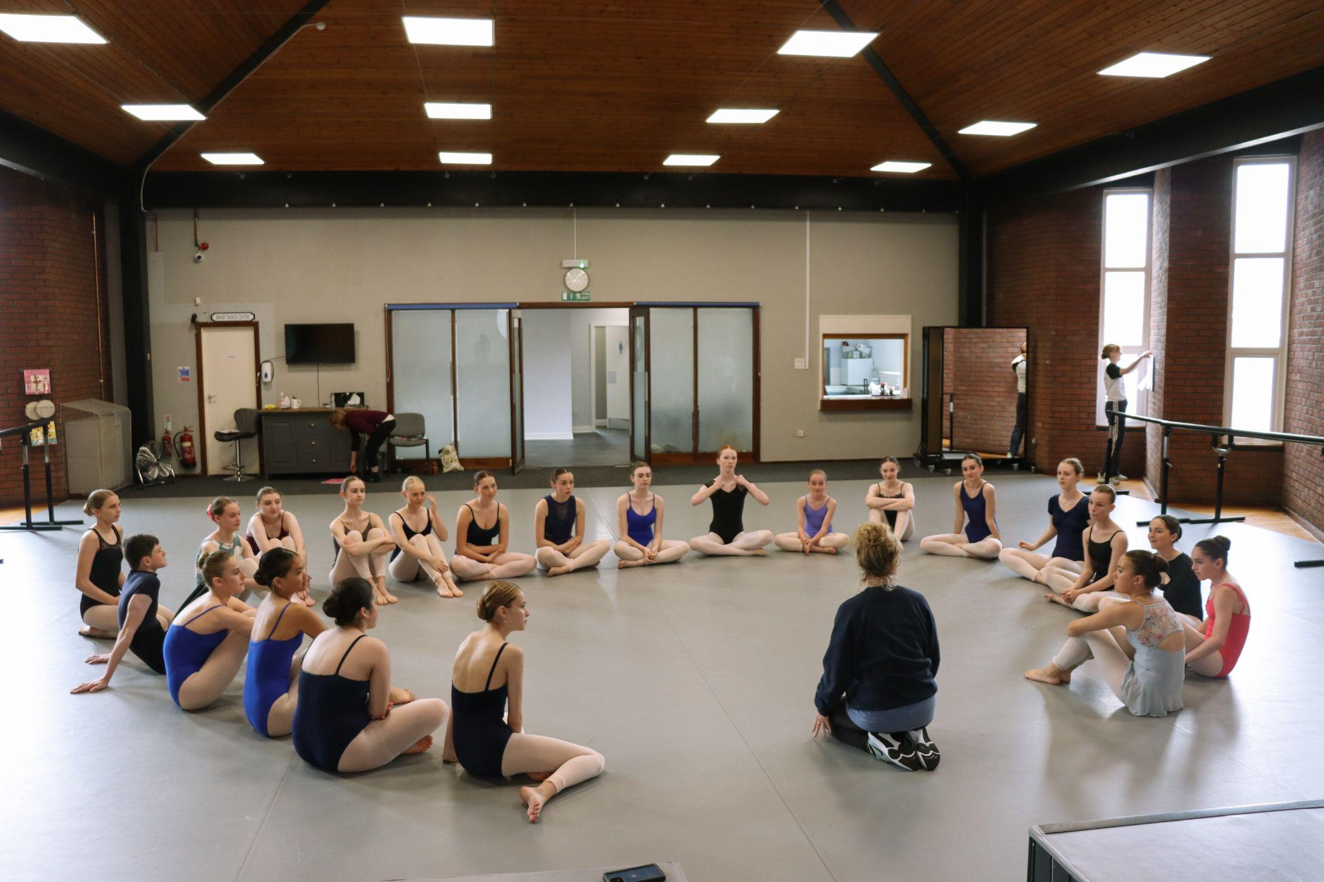
- A ballet class
- A contemporary class | 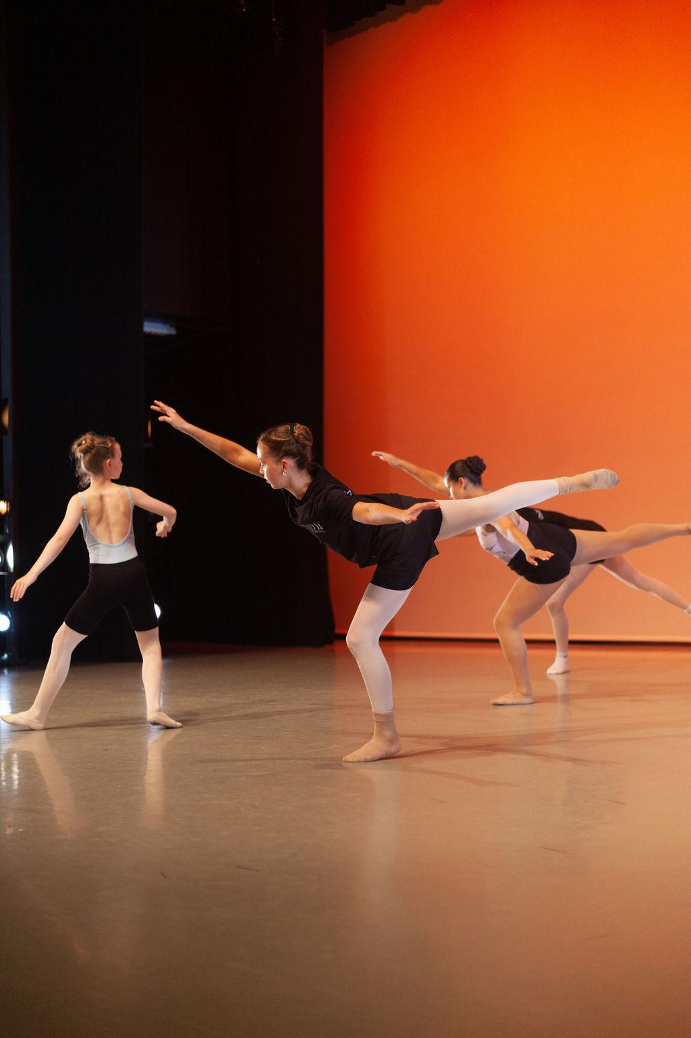
- All auditions will be filmed | 

Where can I audition?

You can audition in person in:  - Leeds  - Birmingham  - Newcastle  - London  - Bath | 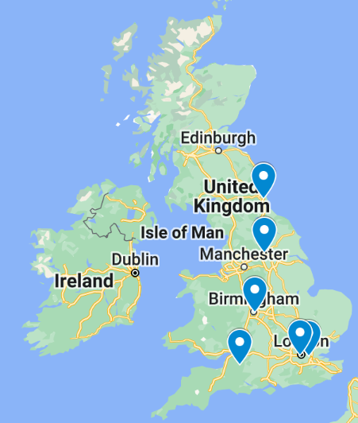
- Or you can audition online | 

What are the audition dates?

Audition Venue | Audition Date | Application Deadline* | Application form:
Leeds*- Northern Ballet,  LS2 7PA | Sunday 26 January 2025 | Monday 20 January 2025 | https://www.tickettailor.com/events/thenationalyouthballetofgreatbritain/1488309
Birmingham * - Birmingham Royal Ballet, B5 4AU | Sunday 9 February 2025 | Monday 3 February 2025 | https://www.tickettailor.com/events/thenationalyouthballetofgreatbritain/1443977
Newcastle - Gateway Studio,  NE8 1EP | Sunday 16 February 2025 | Monday 10 February 2025 | https://www.tickettailor.com/events/thenationalyouthballetofgreatbritain/1488312
London* Acosta Dance Centre, SE18 6BH | Sunday 23 February 2025 | Monday 17 February 2025 | https://www.tickettailor.com/events/thenationalyouthballetofgreatbritain/1488320
Bath - Bath Dance College,  BA3 3QG | Sunday 2 March 2025 | Monday 24 February 2025 | https://www.tickettailor.com/events/thenationalyouthballetofgreatbritain/1488315
London - London Vocational Ballet School, W12 8AP | Sunday 9 March 2025 | Monday 3 March 2025 | https://www.tickettailor.com/events/thenationalyouthballetofgreatbritain/1488323
Online * - Zoom | Sunday 16 March 2025 | Monday 10 March 2025 | https://www.tickettailor.com/events/thenationalyouthballetofgreatbritain/1488325
* Accessible venue

Please see our Frequently Asked Questions for more information:
Easy Read FAQs Word Document
Easy Read FAQs PDF Document



Access Support for applications

- A video description of this information can be found here.

- If you need help with the form please contact us at admin@nationalyouthballet.org.uk

- You can share your access needs in our form

- You can share an access rider

- There is a description of how to make an access rider on this website page: https://weareunlimited.org.uk/resource/creating-your-own-access-rider



Audition Cost:

- Non-refundable audition fee: £40

Performance Company Cost:

- Stay at Elmhurst: £846

- Stay at home: £660

Help to pay:

- We can help you to pay course fees

- You need to fill out this form if you need help with your fees

- The deadline for the form is: Friday 21 March 2025.

- If you need support with the form please contact us at: admin@nationalyouthballet.org.uk

